**Certificate manager & Route 53 project**

**Created complex architecture with VPC and launching instances using auto scaling group in private subnet, managing traffic with the help of load balancer in private subnets. Static website has been hosted on both private instance using http server.**

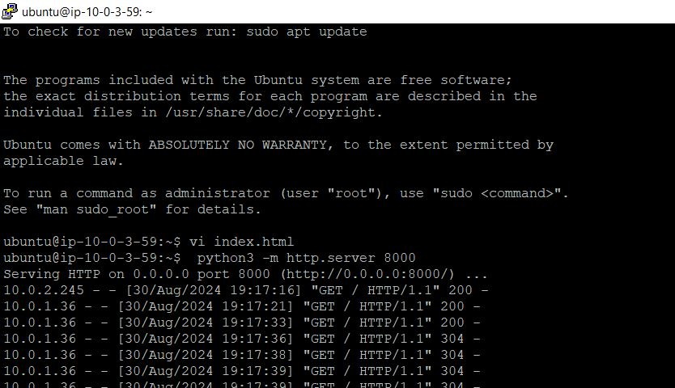

**Traffic has managed using load balancer.**

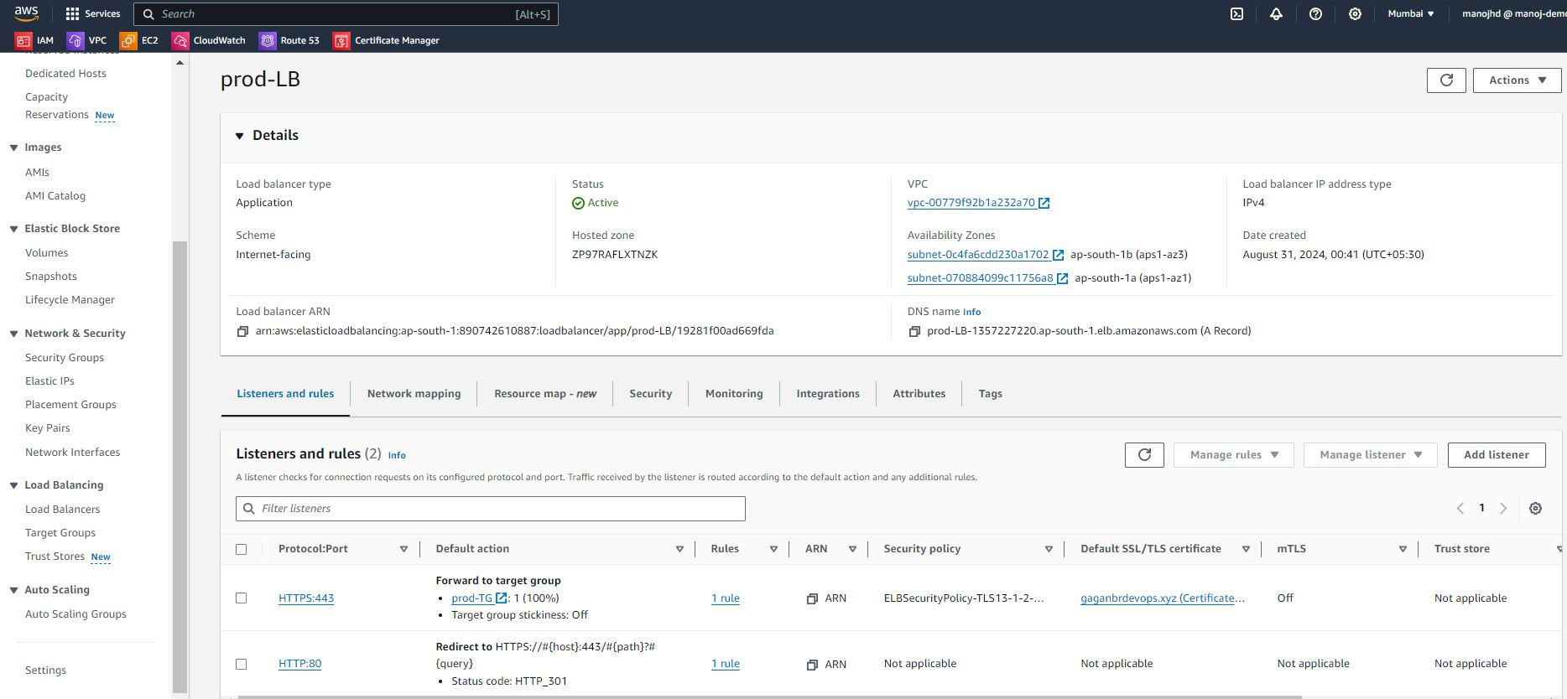

**Instances are scale up and scale down depending on traffic using auto scaling group.**

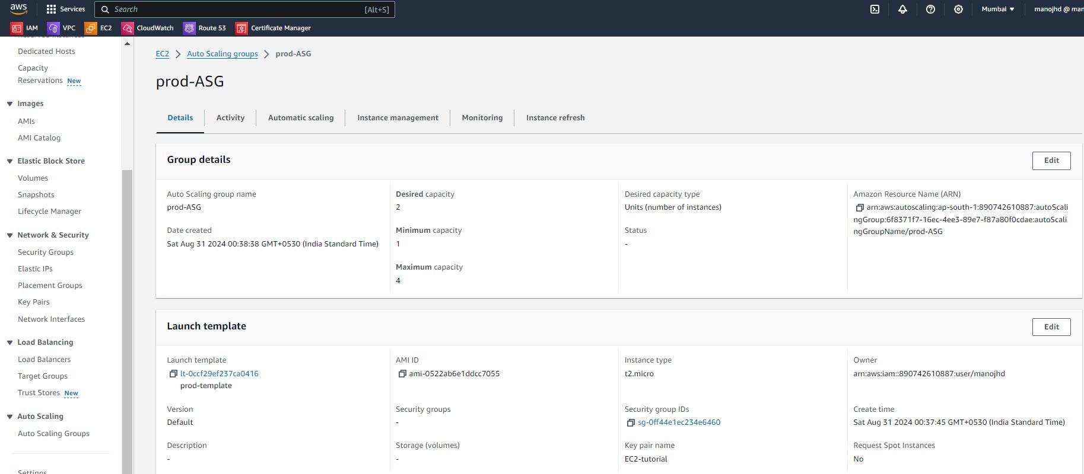

**Website hosted in server is accessible with domain name by using Route 53 service.**

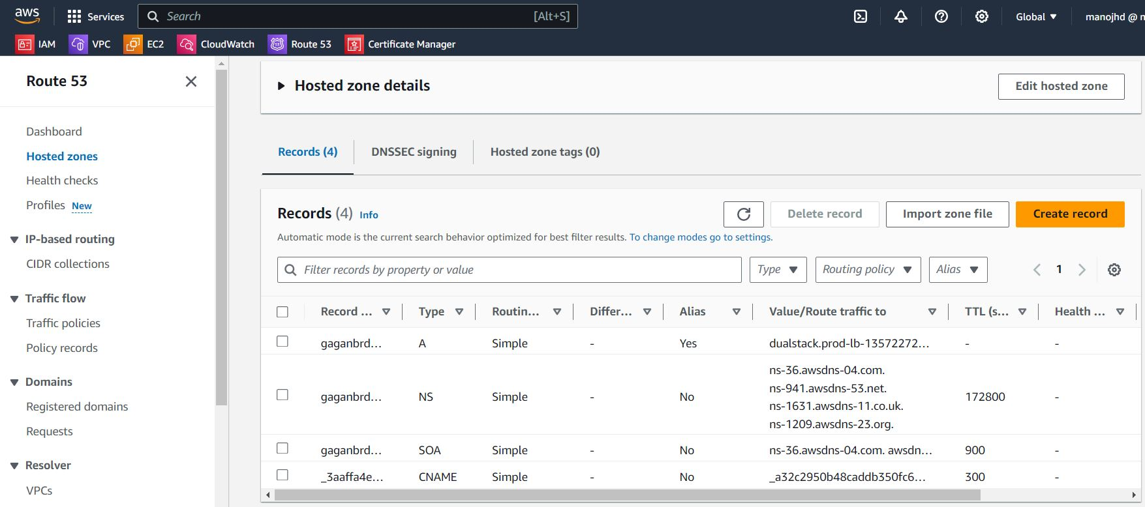

**SSL certificate has been created using Certificate manager service to prevent the application using https protocol.**

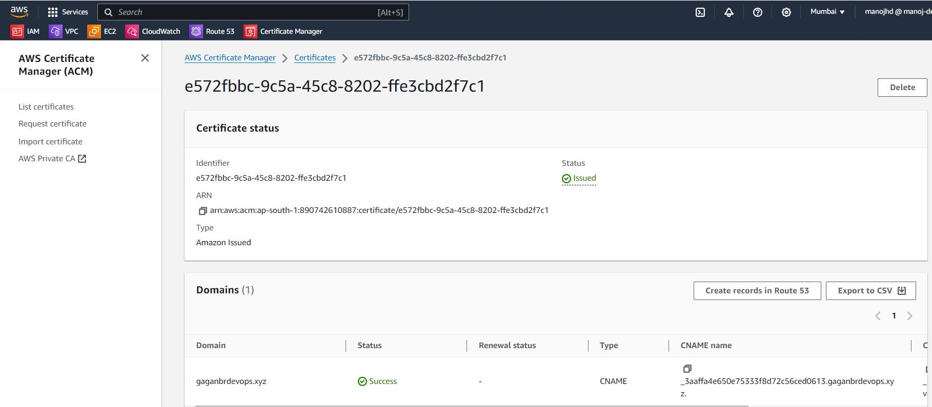

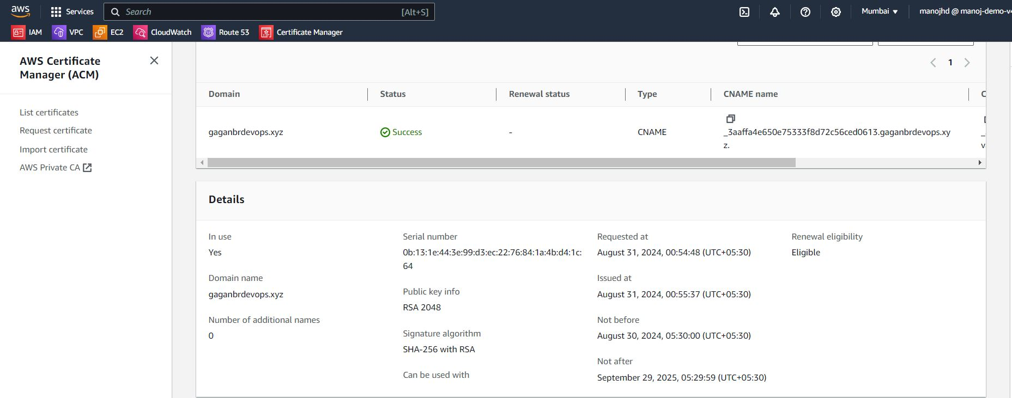

**Website is accessible from https protocol.**

